**DAILY ONLINE ACTIVITIES SUMMARY**

|  |  |  |  |  |  |  |  |  |
| --- | --- | --- | --- | --- | --- | --- | --- | --- |
| **Date:** | **12-06-2020** | | | | | **Name:** | **pallavi** | |
| **Sem & Sec** | **6th sem ‘A’ sec** | | | | | **USN:** | **4AL17CS056** | |
| **Online Test Summary** | | | | | | | | |
| **Subject** | |  | | | | | | |
| **Max. Marks** | |  | | **Score** | | |  | |
| **Certification Course Summary** | | | | | | | | |
| **Course** | **Python for machine learning** | | | | | | | |
| **Certificate Provider** | | | **Great learning academy** | | **Duration** | | | **5hr** |
| **Coding Challenges** | | | | | | | | |
| **Problem Statement:**  1.Write a Python program to implement Magic Square  2..Python program to print the pattern  3.Write a Java program to find maximum width of a binary tree | | | | | | | | |
| **Status:completed** | | | | | | | | |
| **Uploaded the report in Github** | | | | | **yes** | | | |
| **If yes Repository name** | | | | | <https://github.com/pallavi056/DAILY_STATUS> | | | |
| **Uploaded the report in slack** | | | | | **yes** | | | |

Online Test Details:

Certification Course Details:

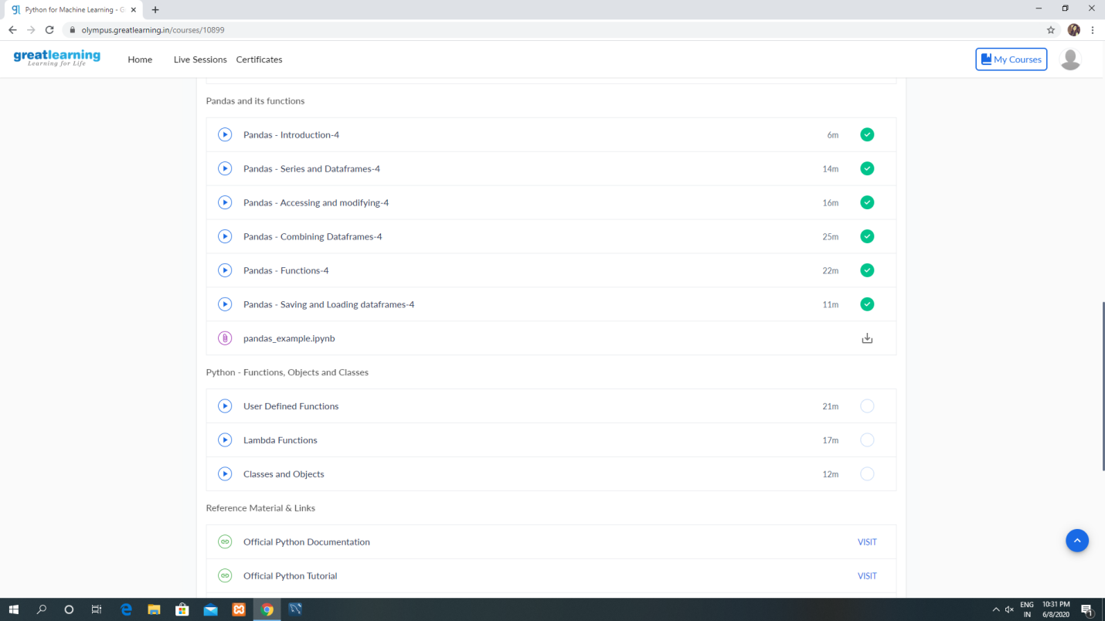

Coding Challenges Details:

[https://github.com/pallavi056/DAILY_STATUS/tree/master/12-06-2020/ONLINE%20CODING](https://github.com/pallavi056/DAILY_STATUS/tree/master/12-06-2020/ONLINE CODING)